**SHIP CHANDLING**

“Lanka Shipping & Global Logistics (Private) Limited” unique style of ship chandling operations into all international ports(Colombo, Galle, Hambantota, Trincomalee & Puttalam) of Sri Lanka. The company is operated on a 24/7 - 365 basis and is dedicated to providing high quality solutions, services and products to the marine and offshore industry of the country. Our highly experienced and competent cadre of personnel are deeply focused on delivering on-time performance with the utmost care, efficiency and cost effectiveness.

We work in extreme close cooperation with the Sri Lanka Ports Authority, Customs, Navy, Ministry of Shipping, Colombo Dockyard and other industry related personnel, whose assistance is crucial for the smooth handling and quick turnaround of vessels at our ports. Anchor Marine also gives priority in keeping close interpersonal business relationships with our clients in order to cater to their expectations and needs in a more customized and individualized manner

* Break bulk operations
* Technical Services – maintenance and repairs
* Crew Change
* Cash to Master
* Repairs and Dry docking
* Clearance & delivery ship spares
* Bunker supply (LSHFO 180 cst/ 380cst/LSMGO)*
* Ship Tank Cleaning
* LSA & FFA Servicing
* Ship’s Stores - catering, engine and deck
* Waste Oil Removal
* Hull Cleaning
* Fresh Water
* Charts & Publications
* Garbage
* Lubricating Oil

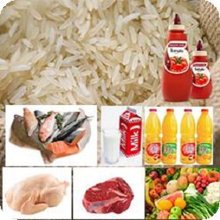1. Provisions

Our range includes fresh, frozen and dry stores, meat from best

quality producers, fish straight from our local fishermen, fruit and

vegetables from our farmers and dry stores, general groceries,

beverages and juices, dairy goods, confectionary and gourmet foods

from local and imported sources.

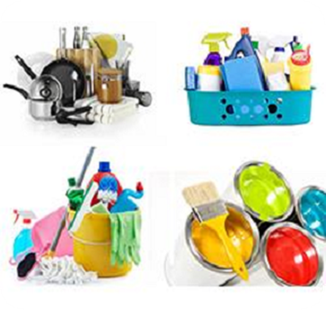

2. Cabin Stores

We can arrange from a wide range of world class and top quality cabin

stores to name a few including electrical appliances, linens, galley supplies,

cleaning products and consumables, dishware and cutlery, garbage bags

and toiletries at competitive prices.

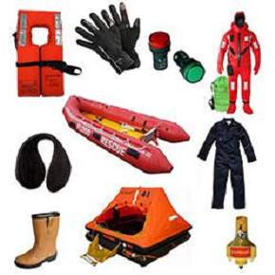3. Safety & Life Saving Equipment’s

We can offer a full range of SOLAS and local authority approved

lifesaving equipment to suit your needs. Lifejackets, Immersion suits,

Rescue boats & Manoverboards, Liferafts, Lifebuoy lights and Signal

lamps, Boiler suits, Safety shoes, Gloves and Ear muffs of well known

and approved are available with our suppliers.

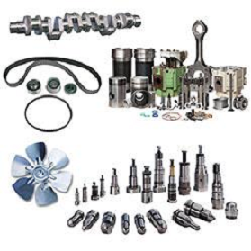

4. Deck & Engine Stores

We have access to a full range of deck and engine stores and all ship

chandlery lines are available at competitive prices with short lead times.

Our range includes products from the IMPA / ISSA stores catalogue.

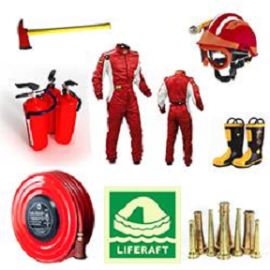5. Fire Fighting Equipment’s

We supply a full range of certified fire fighting equipment’s, including

extinguishers, axes, fire suits, nozzles, hose, helmets and boots, fire

blankets and IMO signage. We can also arrange servicing of all

extinguishers, Co2 and Halon fixed systems through approved

service agents.

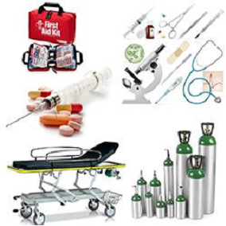6. Medical Stores

We can source and deliver to your vessel an excellent range of medical

stores including first aid kits, hospital supplies, reference books & texts,

medical drugs, stretchers, anti sea sickness tablets, medical oxygen and

vitamins which are approved by a medical practitioner.

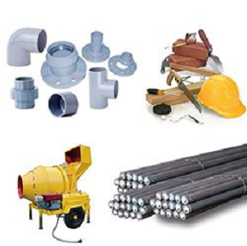7. Construction Materials

We can also deliver any sort of construction materials as per your

requirement within the best time.

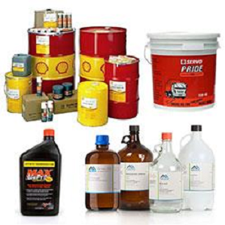

8. Chemicals & Oils

We offer chemicals, additives, lubricants, grease, hydraulic fluids and diesel

and engine oils in 1, 5, 20 or 210 litre drums. Our range includes all

available Sri lankan / Indian and a few international brands

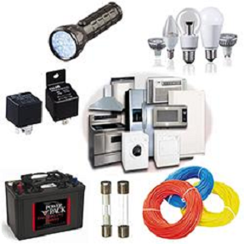9. Electrical Stores

We have a good range of electrical stores including appliances,

batteries, cables, switches, fuses, lamps, torches, tools, relays,

casings and other accessories of Indian and foreign manufacturers.

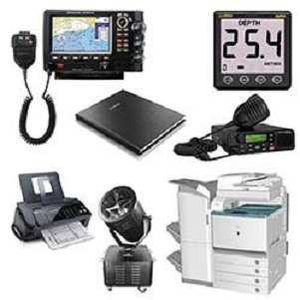10. Electronics & Navigational Supplies

We, can deliver on time and at competitive prices a huge range of

electronics and navigation supplies including Radars, Depth Sounders, GPS

VHF, UHF Radios, Searchlights, Log books, Charts, Photocopiers and Fax

machine consumables, etc